7. Methods

7.5 Pade Approximants

Question 1:

$f_{1}\left(x\right)={\left(1+x\right)}^{\frac{1}{2}}$

$$f_{1}\left(0\right)=1$$

${f^{'}}_{1}\left(0\right)=\frac{1}{2}{\left(1+\left(0\right)\right)}^{-\frac{1}{2}}=\frac{1}{2}$

${f''}_{1}\left(0\right)=-\frac{1}{4}{\left(1+\left(0\right)\right)}^{-\frac{3}{2}}=-\frac{1}{4}$

$$f_{1}^{\left(n\right)}\left(0\right)={\left(-1\right)}^{\left(k\right)}2^{-k}\prod_{n=0}^{k-1}{\left(2n-1\right)} for k≥1$$

Therefore, $$c_{k}=\frac{1}{k!}{\left(-2^{-1}\right)}^{\left(k\right)}\prod_{n=0}^{k-1}{\left(2n-1\right)} for k≥1$$

and $c_{0}=1$.

1. Radius of convergence: 1; The distance to the nearest singularity/branch point for $f_{1}\left(x\right)$ is 1 at $x=-1$ on a complex plane.

We will require |x| <1 when we use the power series to estimate $f_{1}\left(x\right)$ otherwise the approximation diverges.

$$\sqrt{2}=1.414213562$$

|  |  |  |
| --- | --- | --- |
| $$N$$ | $\sum_{k=0}^{N}{c_{k}}$ | Error |
| 5 | 1.42578125 | -0.011567687 |
| 10 | 1.409931182861328 | 0.0042823795 |
| 20 | 1.412667185988539 | 0.0015463763 |
| 50 | 1.413817654785574 | 0.0003959075 |
| 100 | 1.414073047717716 | 0.0001405146 |
| 150 | 1.414136978762613 | 0.0000765836 |

Table 1: partial sums as N increases

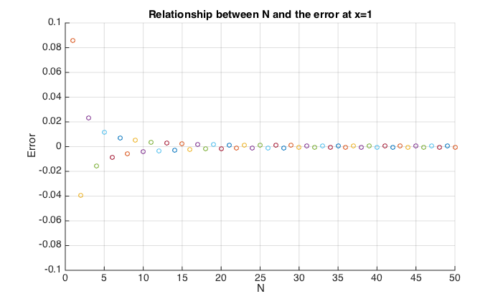

Figure 1: Relationship between N and the error at x=1

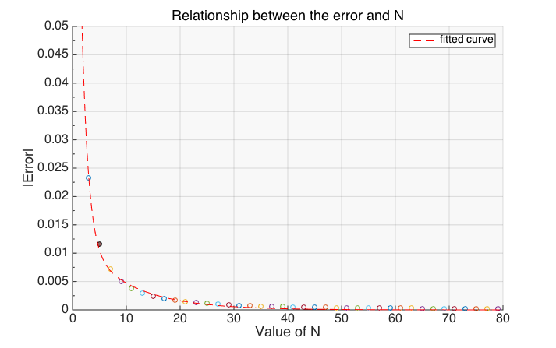 From the graph, the magnitude of the error decreases exponentially as the value of N increases linearly and it also shows a sign changing oscillation on the error as N increases and those results can be explained from the coefficient formula.

Deriving from the formula, we get:

$$c_{k}=\frac{1}{k}\left(-1){(2}^{-1}\right)\left(2\left(k-1\right)-1\right)c_{k-1}=Ac_{k-1} for k≥1$$

1. $\left|A\right|=\left|\frac{2k-3}{2k}\right|<1$; b) $\left|A\right|→1 as k→∞$; c) factor of (-1)

From b) and c), we can deduce that the partial sum should converges as N tends to large because each of the successive terms are (nearly fully) cancelling each other out. Due to the three conditions and $Error=\sum_{i=N+1}^{∞}{c_{i}}$, the error should decreases exponentially (to 0) and shows a sign-changing oscillation as N increases.

Question 2: (assumed L=M unless indicated otherwise)

|  |  |  |
| --- | --- | --- |
| $$L$$ | $Pade Approximant R_{L,L}$ | Error |
| 3 | 1.414201183431953 | 1.237894114258786e-05 |
| 5 | 1.414213551646055 | 1.072704036708672e-08 |
| 8 | 1.414213562372821 | 2.740030424774886e-13 |
| 10 | 1.414213562373095 | 4.440892098500626e-16 |
| 15 | 1.414213562373095 | -2.22044604925031e-16 |
| 20 | 1.414213562373095 | -2.22044604925031e-16 |

Table 2: Pade Approximation's Error as L increases

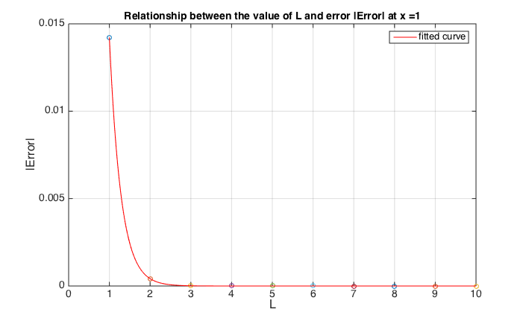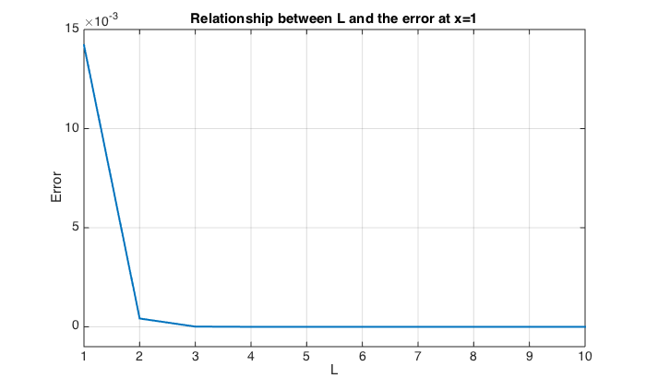

Figure : Relationship between L and the magnitude of error at x=1

Figure : Relationship between L and the error at x=1

From the graphs, we can see the error reduce significantly as L increases. By plotting a curve of best fit, we can see there is an exponential decreases as L increases. The exponential decrease could be explained by the same reason in Q1 as $R_{L,L}\sim Powerseries(2L)$ and $rror=\sum_{i=2L+1}^{∞}{{c'}_{i}}$. Although the error did not improve in exponential manner for L greater than 10, I believe it is due to the inaccurate result suffered from the matrix for solving the system of differential equations getting close to singular. We shall investigate more on why the change in magnitude of the error comparing with the power series.

What is the smallest value to which the error can be reduced?  
 What determines this smallest value?

|  |  |
| --- | --- |
| Iteration | Error |
| 5 | -1.23430499847512e-05 |
|  | -5.29647132990662e-05 |
|  | -9.44918288578296e-05 |
|  | -9.06946369049941e-05 |
|  | -5.06061841238004e-05 |
|  | -1.65426314057550e-05 |
|  | -3.02905850522778e-06 |
|  | -2.77032515608707e-07 |
|  | -9.72729302810274e-09 |
|  | -5.60841668160196e-11 |

|  |  |
| --- | --- |
| Iteration | Error |
| 1 | 7.97188565670195e-06 |
|  | 3.42532343592588e-05 |
|  | 6.11993341672699e-05 |
|  | 5.88358665660897e-05 |
|  | 3.28892688872149e-05 |
|  | 1.07731030737142e-05 |
|  | 1.97715730553159e-06 |
|  | 1.81298176543277e-07 |
|  | 6.38474620117571e-09 |
|  | 3.69400455507437e-11 |

|  |  |
| --- | --- |
| Iteration | Error |
| 10 | 7.03476546956977e-06 |
|  | 3.03261488832999e-05 |
|  | 5.43869966571571e-05 |
|  | 5.25142833502190e-05 |
|  | 2.95050447244694e-05 |
|  | 9.72300833770241e-06 |
|  | 1.79746675428985e-06 |
|  | 1.66307431517344e-07 |
|  | 5.92396986990842e-09 |
|  | 3.47948155534163e-11 |

After running the iterative improvement, it does not improve the error much after 5 iterations. The methods did not show any significance of improvement on the error as the number of iteration increases.

Comparing the tables from Q1 and Q2, we can clearly see that Pade approximation converges to the actual value quicker than the power series approximation by far. From the samples I generated, the error of Pade approximation is at least less than ${10}^{-5}$ while for power series, we will need up to and include the 150 terms for an approximation having a same accuracy. Therefore, regarding to get the most accurate approximation, I will suggest the use of Pade approximation over the power series.

If we aim to estimate for $\sqrt{2}$ to specified accuracy, I will suggest the use of power series because it is easier to identify the exact number of terms which we need to include for an estimation to a specified accuracy. With the use of the recurrence formula stated in Q1, we can easily find the smallest N such that $|A^{N}|$ is smaller than the required accuracy. While with Pade approximation, it requires more work to recognise the number of terms needed for an approximation to required accuracy.

In addition, Pade approximation works at order o(M(M+L)) which includes solving M simultaneous equations for Q and L+1 calculations for P while power series requires only N calculations for each approximation. It requires more work for Pade approximation than power series although Pade approximation gives us an incomparably more accurate result than using power series.

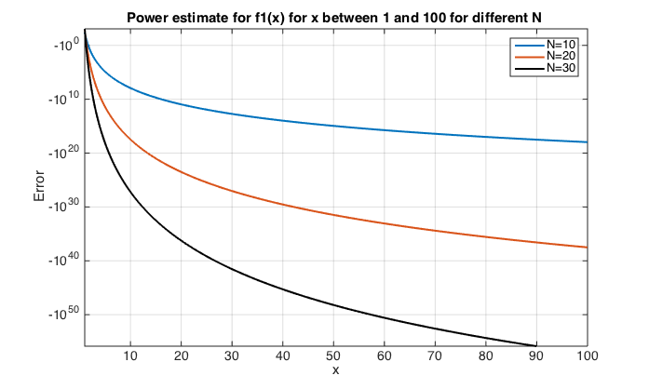Question 3:

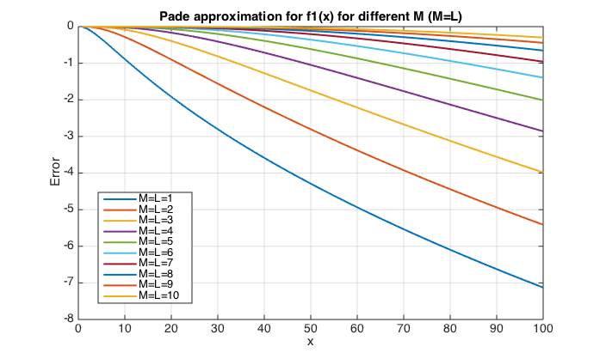

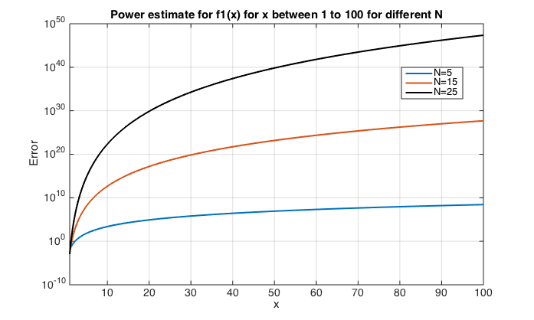

Characteristics obtained from the graphs:

For power series approximation:   
1a) the magnitude of the error increases exponentially as x increases linearly  
2a) the magnitude of the error increases exponentially as N increases linearly  
3a) a sign-changing oscillation on the error as N increases

For Pade approximation:  
1b) the magnitude of the error increases logarithmically as x increases linearly  
2b) the magnitude of the error decreases at inverse logarithmical manner as L increases linearly

Comparing two graphs, we can see the magnitude of the error in power series is greater than in Pade approximation overall from x=1 to 100. The difference in error from the two approximations diverges in an exponential manner as x increases with the range of error for pade approximation and power series approximation varies from 0 to -8 and 0 to ${10}^{47}$ respectively. This shows Pade approximation gives higher accuracy than power series approximation.

Observation 1a) and 1b) can be explained by the fact that the rate of error reduces/ increases is affected by the distance between the evaluated point and the radius of convergence. The further we evaluated from the radius of convergence, the quicker the error increases.

There is a significant difference between the number of terms being considered and the magnitude of error within two approximation. For x greater than 1, the error in the Pade approximation decrease as more terms being considered while the error in power series approximation increases in an exponential manner as N increases. This is because the more terms we accepted in power series (which means the expansion is at higher order of x), the greater divergence we get as x being greater than 1 and the coefficient of the expansion does not tend to 0 as quick. The exponential increases can be explained by $$\sum_{i=0}^{N}{a_{i}{\left(x\right)}^{i}}-\sum_{i=0}^{N}{a_{i}{\left(x+ε\right)}^{i}}=o(x^{N-1})$$

(((((((((Why pade decrease?))))))))

On the other hand, from the graph, we can see the power series approximation with N being odd tends to overestimation while N being even leads to underestimation. This could be because the coefficient of the power series we used to approximate has a factor of ${\left(-1\right)}^{N}$ and given that the series diverges, the leading term of the polynomial dominates the sign of the series which caused oscillate around the actual result as N changes.

In conclusion, pade approximation gives a better approximation than power series although both approximation shows some extends of divergence from the actual result from the graph as x increases which is due to the distance from the evaluated point to the radius of convergence increases.

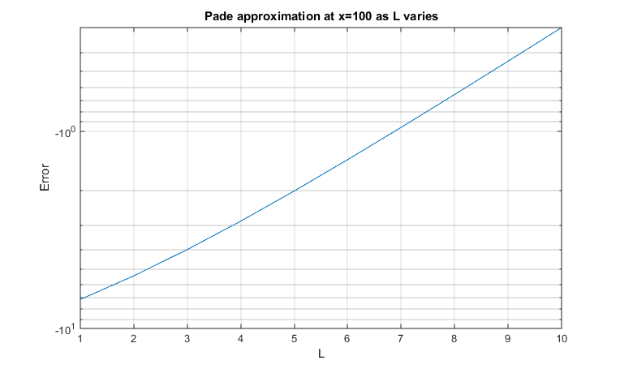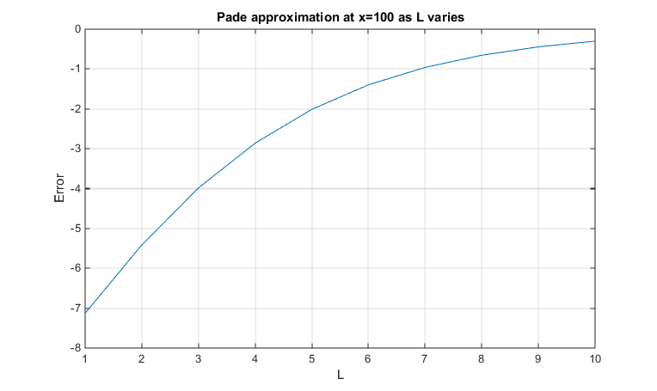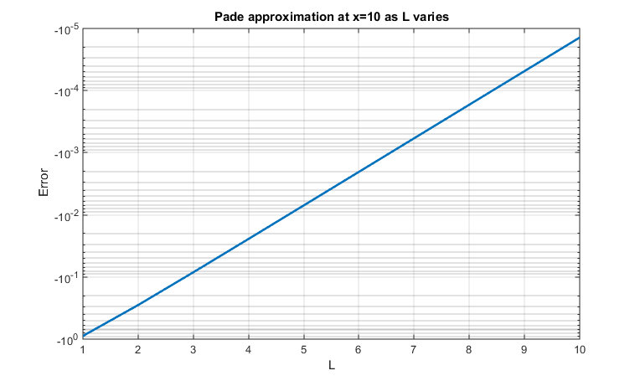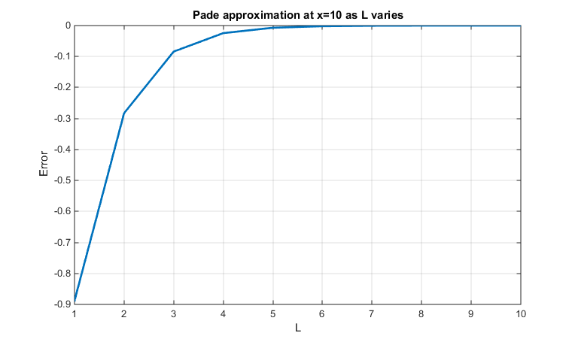

Similar to part 1, from the two we can see the magnitude of the error decreases at inverse logarithmical manner as L increases. The reason behind the rate of the error decrease being exponential can be explained by the ++++

Investigate how pade error varies as L increases;

Implications for using pade to estimate f_1 for large x.

Implication: no matter how large x is, we can always increase L to improve the relative error of the approximation at certain x with a inverse log relationship

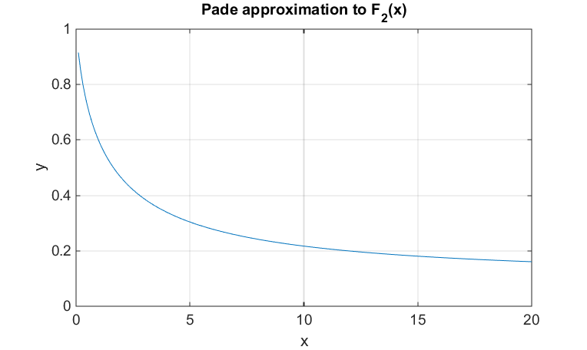Question 4:

From the table, we can easily identify that the relative error in the truncated power series is, again, incomparably large (varying from ${10}^{9}-{10}^{32}$) comparing with the relative error occurs in Pade approximation for all value of x across 0.1 to 20. Although the error in power series approximation starts off relatively low when x is small, it experiences an exponential increase as x increases and diverges to over ${10}^{31}$. This is because the partial sum of the power series diverges for any non-zero x. The series has a better approximation if we include less term in the series with small x because each extra term we consider, we are adding/substracting a value of $k!x^{k}=kx\left(k-1\right)!x^{k-1}=\left(kx-1\right)\left(k-1\right)!x^{k-1}+\left(k-1\right)!x^{k-1}$ to the partial sum. The partial sums should remain stable and relatively accurate up to the smallest value of $k$ such that $kx>1$. Example as followed:

|  |  |  |  |  |  |
| --- | --- | --- | --- | --- | --- |
| X | Actual | N=3 | N=4 | N=5 | N=6 |
| 0.1 | 0.91563334 | 0.914000 | 0.916400 | 0.91520 | 0.915920 |
| 0.2 | 0.85211088 | 0.832000 | 0.870400 | 0.83200 | 0.878080 |
| 0.3 | 0.80118628 | 0.718000 | 0.912400 | 0.62080 | 1.145680 |

From the integral expression of $f_{2}(x)$, we can deduce that $f_{2}(x)$ is a decreasing function in x. However, according to the power series, it shows a divergent behaviour as x increases. Therefore, as a basis for calculating $f_{2}(x)$, truncated power series do not give much useful information at all which can also be reflected on the magnitude of error in the table.

Regarding the use of Pade approximation to $f_{2}(x)$, it shows a promising accuracy to the actual value as x increases. A clear trend of $f_{2}(x)$ being a monotonic decreasing function in x is clearly reflected from the graph which matches with our observation of the behaviour of $f_{2}(x)$. As x increases, although the relative error increases, it still under a reasonable range at x=20 with around 24%. I believe the relative error will increase as x increases but a clear sign of convergence to 0 is spotted from the approximation.

Even though the order of Pade approximation is higher than the power series approximation, as a basis for calculating $f_{2}(x)$, we should use the Pade approximation over the power series approximation as we can get barely any information from the latter method.

Question 5:

|  |  |  |  |  |  |  |  |
| --- | --- | --- | --- | --- | --- | --- | --- |
| **X** | **Actual Value** | **Pade Approximation (L=M=10)** | | | **Power Series Approximation (N=15)** | | |
| $$f_{2}\left(x\right)$$ | $$f_{2}\left(x\right)$$ | **Error** | **(%)** | $$f_{2}\left(x\right)$$ | **Error** | **(%)** |
| 0.1 | 0.9156334 | 0.915633 | -6.06019E-08 | -6.61858E-06 | 0.91484044 | -0.00079 | -0.0866 |
| 0.2 | 0.85211088 | 0.852111 | 1.79275E-09 | 2.1039E-07 | -31.42068165 | -32.2728 | -3787.39 |
| 0.3 | 0.80118628 | 0.801186 | 1.3659E-08 | 1.70484E-06 | -15385.95186 | -15386.8 | -1920496 |
| 0.4 | 0.75881459 | 0.758815 | 1.32262E-07 | 1.74301E-05 | -1205207.548 | -1205208 | -1.6E+08 |
| 0.5 | 0.72265723 | 0.722658 | 6.24763E-07 | 8.64536E-05 | -35245832.94 | -3.5E+07 | -4.9E+09 |
| 0.6 | 0.69122594 | 0.691228 | 1.98126E-06 | 0.000286629 | -553748521.2 | -5.5E+08 | -8E+10 |
| 0.7 | 0.66351027 | 0.663515 | 4.91558E-06 | 0.000740844 | -5.67E+09 | -5.7E+09 | -8.5E+11 |
| 0.8 | 0.6387911 | 0.638801 | 1.02389E-05 | 0.001602852 | -4.25E+10 | -4.2E+10 | -6.7E+12 |
| 0.9 | 0.61653779 | 0.616557 | 1.88182E-05 | 0.003052243 | -2.51E+11 | -2.5E+11 | -4.1E+13 |
| 1 | 0.59634736 | 0.596379 | 3.15238E-05 | 0.005286148 | -1.23E+12 | -1.2E+12 | -2.1E+14 |
| 2 | 0.46145532 | 0.46196 | 0.000505175 | 0.109474403 | -4.15E+16 | -4.1E+16 | -9E+18 |
| 3 | 0.38560201 | 0.387274 | 0.001671949 | 0.433594569 | -1.84E+19 | -1.8E+19 | -4.8E+21 |
| 4 | 0.33522136 | 0.338565 | 0.003343908 | 0.997522332 | -1.38E+21 | -1.4E+21 | -4.1E+23 |
| 5 | 0.29866975 | 0.303969 | 0.005299605 | 1.774402977 | -3.94E+22 | -3.9E+22 | -1.3E+25 |
| 6 | 0.27063301 | 0.278017 | 0.007384201 | 2.728492272 | -6.08E+23 | -6.1E+23 | -2.2E+26 |
| 7 | 0.24828135 | 0.257783 | 0.009501752 | 3.827009971 | -6.15E+24 | -6.1E+24 | -2.5E+27 |
| 8 | 0.22994778 | 0.241543 | 0.01159563 | 5.042723063 | -4.56E+25 | -4.6E+25 | -2E+28 |
| 9 | 0.2145771 | 0.228211 | 0.013633636 | 6.353723642 | -2.67E+26 | -2.7E+26 | -1.2E+29 |
| 10 | 0.20146425 | 0.217063 | 0.015598475 | 7.7425525 | -1.30E+27 | -1.3E+27 | -6.4E+29 |
| 11 | 0.19011779 | 0.2076 | 0.017481876 | 9.195286529 | -5.43E+27 | -5.4E+27 | -2.9E+30 |
| 12 | 0.18018332 | 0.199464 | 0.019281009 | 10.70077346 | -2.00E+28 | -2E+28 | -1.1E+31 |
| 13 | 0.171398 | 0.192394 | 0.020996304 | 12.25002849 | -6.66E+28 | -6.7E+28 | -3.9E+31 |
| 14 | 0.16356229 | 0.186192 | 0.022630063 | 13.83574571 | -2.02E+29 | -2E+29 | -1.2E+32 |
| 15 | 0.15652164 | 0.180707 | 0.02418564 | 15.45194661 | -5.70E+29 | -5.7E+29 | -3.6E+32 |
| 16 | 0.15015426 | 0.175821 | 0.025666934 | 17.09371014 | -1.50E+30 | -1.5E+30 | -1E+33 |
| 17 | 0.14436271 | 0.171441 | 0.027078074 | 18.75697256 | -3.73E+30 | -3.7E+30 | -2.6E+33 |
| 18 | 0.13906806 | 0.167491 | 0.028423156 | 20.43830595 | -8.79E+30 | -8.8E+30 | -6.3E+33 |
| 19 | 0.13420555 | 0.163912 | 0.029706212 | 22.1348607 | -1.98E+31 | -2E+31 | -1.5E+34 |
| 20 | 0.12972152 | 0.160653 | 0.030931099 | 23.84423137 | -4.27E+31 | -4.3E+31 | -3.3E+34 |

Relative Error (%)=(Errror/Actual Value)*100